**Joona Räisänen, M2080, HTK18S, Module 2 Assignment**

**Asset 1:** Stylized Mug

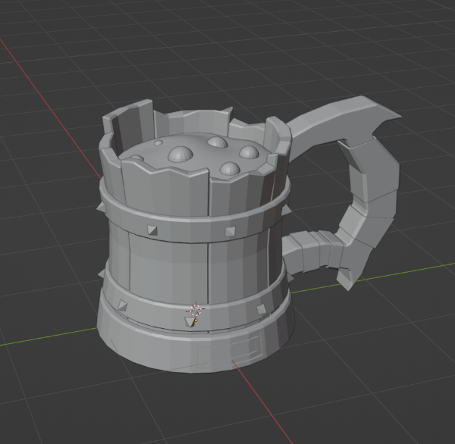

**Asset 2:** Stylized Axe

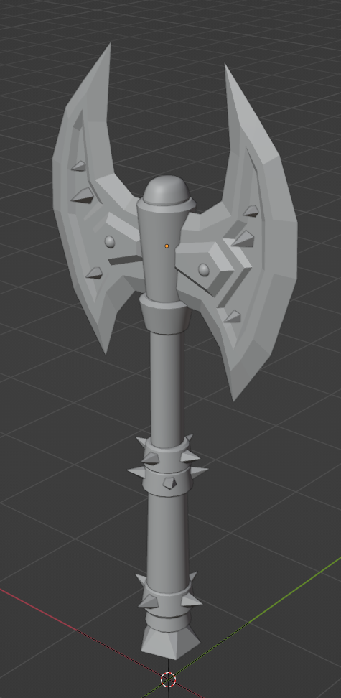

I have no knowhow so I followed a youtube tutorial from Chaakoraa

Mug tutorial: <https://www.youtube.com/watch?v=taTUMvf98hc>

Axe tutorial: <https://www.youtube.com/watch?v=VRDIratUCMA>